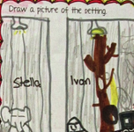
Visualization Response Rubric
Criteria | 1 | 2 | 3 | 4
a simple picture of a scene in the story | No picture | Picture was done but not connected to description | Picture was good and connected to description | Clear picture and clear connections
Describe in two or three sentences what is happening in the scene. | Description was unclear or did not refer to story scene. | Sentences described a story scene, but were too brief to be clear, or did not clearly explain the picture. | Sentences described a story scene, the picture, and had some story detail | Sentences described a story scene, a clear picture, and had excellent use of story detail
Tell why the scene is important – refer to characters and details in the story. | No indication of why the scene is important | Some indication of why the scene is important, but little story detail | Greater indication of why the scene is important, and more story detail | Excellent argument for why the scene is important, and thorough story detail

