Vampire Research
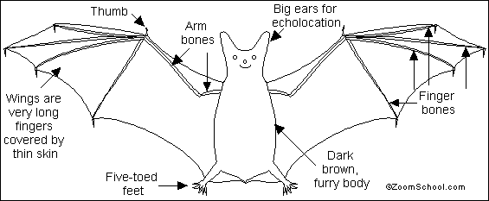

Vampire Bats are small flying mammals. They give birth to live young and nourish them with milk. They are nocturnal; they are most active at night and sleep during the day hanging upside-down. Vampire Bats live in Central and South America. Vampire Bats are bats who use echolocation—meaning they send out sound waves. If the sound waves hits something solid it will bounce back to the bat. These waves bouncing back will reveal the size of objects and their distance away from the bat.

Anatomy: Bats' wings are long fingers covered by thin skin, and they have furry bodies. These tailless mammals have weak legs and don't walk very well. Vampire Bats have a wingspan of only 8 inches (20 cm). The body is the size of a person's thumb.

Senses/Diet: Vampire Bats can see, but use echolocation as their primary sense in order to find insects and small animals to eat. While flying, these bats send out high-pitched sounds that bounce off other objects. The bat listens for the bounced sound, and can determine where objects are located. People cannot hear these high-pitched sounds. The vampire bat is the only bat (and the only mammal) that eats blood, preying on cattle, horses, large birds and pigs. Vampire bats don't suck animals' blood, they make a small hole with their two very sharp incisor teeth and lap up the blood, which doesn't clot (thicken) because of anti-coagulants (anti-thickeners) in the bat's saliva.
Questions to answer (based on reading):
1. When are bats active? __________________________________________________
2. How do they find their way around? _______________________________________________
3. How big is a vampire bat? _______________________________________________
4. What does the vampire bat eat? __________________________________________
5. How do they get their food? _____________________________________________________________
_____________________________________________________________
_____________________________________________________________

