

**Diagrams**

**Why is this helpful?**

*Insert Photo in this box*

**Table**

**Why is this helpful?** 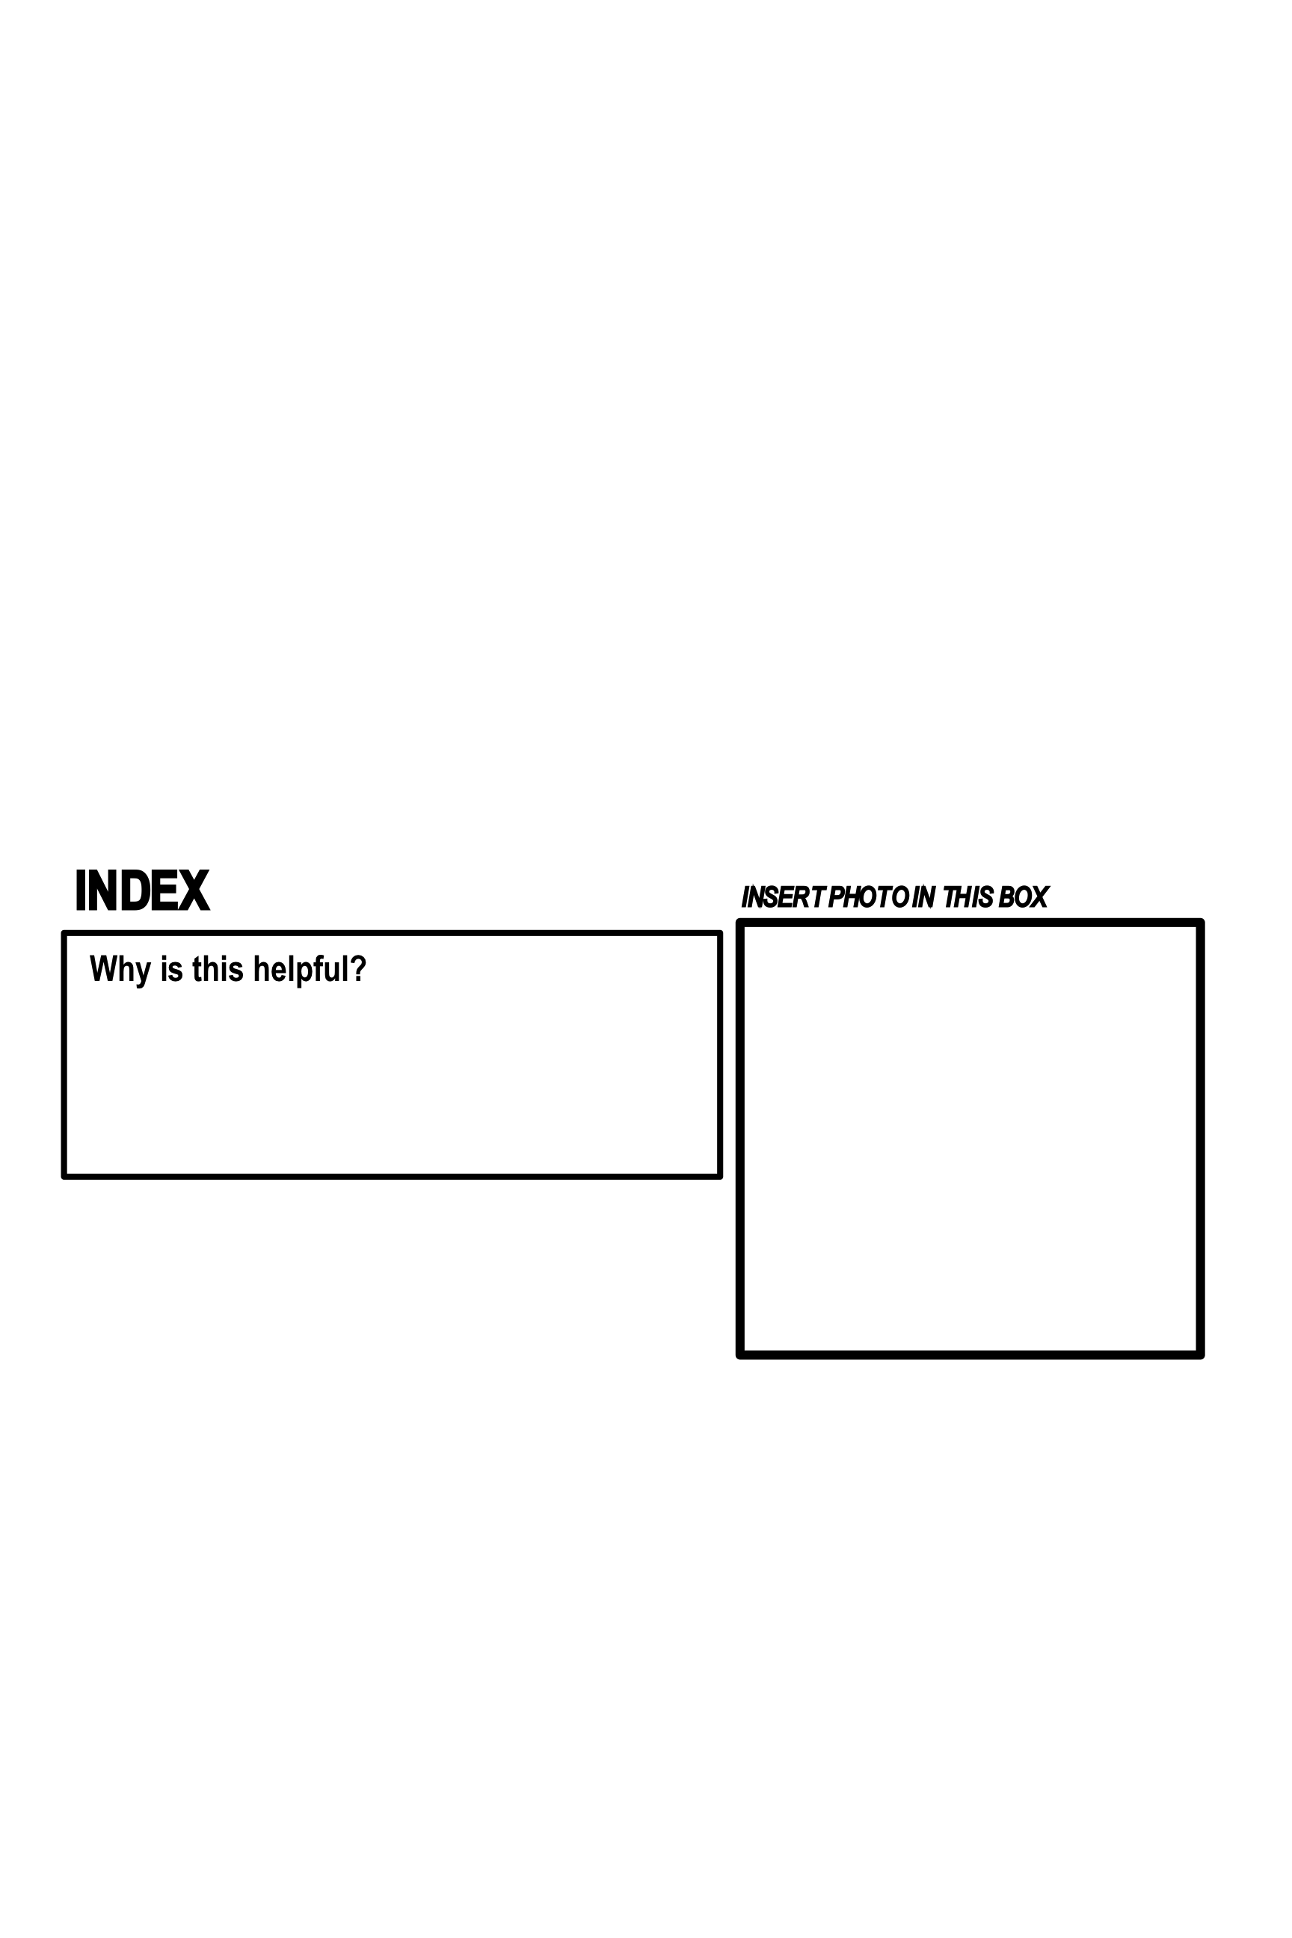

*Insert Photo in this box*

**Bold Print**

**Why is this helpful?** 

*Insert Photo in this box*

***For each feature, find an example in your selection of nonfiction books. Take a photo and insert it into this document.***

***Next, write a sentence to explain how this feature is helpful when looking up information.***

**Text Feature Scavenger Hunt 3**